Dear <last name> family,

Having a teen driver isn’t always easy!

Parents like you naturally worry about their child’s safety, and also about the costs of your insurance. As your agent, I truly understand those concerns.

That’s why I’m letting you know about a special Allstate discount program that’s available only to families like yours with a Minnesota teenage driver.

If your child qualifies, this Allstate program can:
- help your budget, by giving you the maximum discount possible for your
teenage driver.
- improve your child’s odds of staying crash-free, by giving them practical
defensive-driving tips they may not have learned in Driver Education class.

This special program is called the “Young Driver Education Discount.” After years of successfully improving the knowledge and performance of teen drivers in the Twin Cities area, it’s now available to you online.

You can get all the details at this location:
www.DriveSafeRideSafe.com/Allstate

In order to qualify, your son or daughter needs to be 16 - 19 years, have a B average in school, and have no tickets or accidents on their driving record. To get the discount, your teen just watches a video every six months, answers a few quiz questions, and gets a Certificate of Completion to send to me.

This training is truly valuable for your teen driver, not just because of the discount!

Each video gives your teen safety tips and practical defensive driving advice from Veteran Crash Investigator and Driving Safety Expert Mike Pehl.

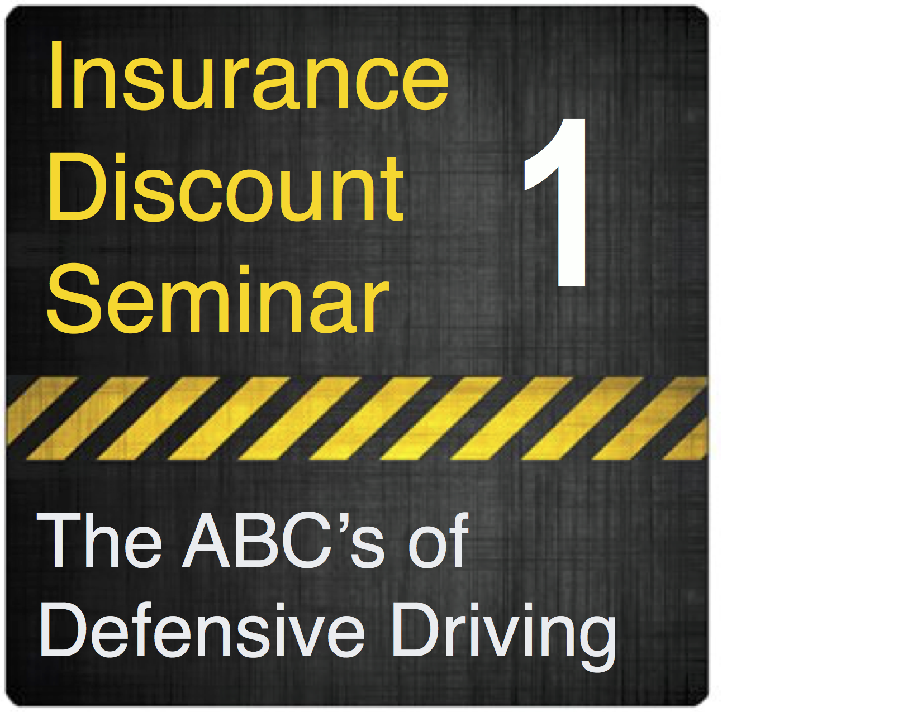
I hope your family can take advantage of this special Allstate program. You can also save an extra $10 on the first online training, “The ABC’s of Defensive Driving” with my personal coupon code:

____________

Please let me know if you have any questions, and thank you for allowing me to serve your family as your Allstate agent!

Sincerely,

